**BHARAT INTERN**

**AN INTERNSHIP REPORT**

***Submitted by***

**Jaimin Prakash Patel**

**200390107017**

***In partial fulfillment for the award of the degree of***

**BACHELOR OF ENGINEERING**

***In***

**Computer Engineering**

**S.P.B. Patel Engineering College, Mehsana**

**Gujarat Technological University, Ahmedabad**

**May, 2023**

**S.P.B. Patel Engineering College**

**Near Shanku’s Water Park, Ahmedabad – Mehsana Highway, Linch, Gujarat**

**CERTIFICATE**

This is to certify that the project report submitted along with the project entitled **Internship at BHARAT INTERN** has been carried out by **Jaimin Prakash Patel** under my guidance in partial fulfillment for the degree of Bachelor of Engineering in Mechanical Engineering, 7th Semester of Gujarat Technological University, Ahmedabad during the academic year 2022-23.

Sign Sign

Prof. First Name Last Name Prof. FirstName Last Name

Internal Guide Head of Department

**Company Certificate**

**Paste your Industry Internship certificate Scanned Copy here**

**S.P.B. Patel Engineering College, Mehsana**

**Near Shanku’s Water Park, Ahmedabad – Mehsana Highway, Linch, Gujarat**

**DECLARATION**

We hereby declare that the Internship / Project report submitted along with the Internship / Project entitled **BHARAT INTERN** submitted in partial fulfillment for the degree of Bachelor of Engineering in **Computer Engineering** to Gujarat Technological University, Ahmedabad, is a bonafide record of original project work carried out by me under the supervision of **Prof. FirstName LastName** & **FirstName LastName (External Guide)** and that no part of this report has been directly copied from any students’ reports or taken from any other source, without providing due reference.

Name of the Student Sign of Student

1. **Jaimin Prakash Patel**  ______________________

**ACKNOWLEDGMENT**

I would like to take this opportunity to express my sincere gratitude and appreciation to all those who have supported and guided me throughout my enriching internship experience in Frontend Development at Bharat Intern. This internship has been an invaluable learning journey, and I extend my heartfelt thanks to the following entities for their contributions:

Bharat Intern:

I extend my gratitude to Bharat Intern for providing me with the opportunity to intern and gain hands-on experience in real-world frontend development projects. The exposure to diverse projects and challenges has significantly contributed to my growth as a frontend developer.

Saffrony Institute of Technology:

I am grateful to Saffrony Institute of Technology for providing me with the foundational knowledge and skills that have enabled me to contribute effectively to the frontend development projects during my internship.

This internship experience has provided me with invaluable insights into frontend development, improved my coding skills, and ignited my passion for creating dynamic and user-friendly web interfaces. The collective support and guidance from all quarters have truly been the cornerstone of my success during this journey.

Jaimin Patel

Enrollment ID: 200390107017

[Date]

**Abstract**

This report contains the work done by the author during his internship at ***BHARAT INTERN****.* It shows the work I did in the company during my internship period. In the report, the author discusses the process of developing the website. The author also discusses the language using for developing the website and the variables are include in languages. It also explains what the author learned during this internship period.

**List of Figures**

Fig 1.1 HTML and CSS................................................................................................2

Fig 1.2 Home page........................................................................................................2

Fig 1.3 Project page......................................................................................................3

Fig 1.4 Contact us page................................................................................................3

Fig 2.1 HTML, CSS and JS.........................................................................................5

Fig 2.2 Home page.......................................................................................................5

**Abbreviations**

HTML Hyper Text Markup Language

CSS Cascading Style Sheet

JS Java Script

**Table of Contents**

Acknowledgement ..........................................................................................................i Abstract..........................................................................................................................ii

List of Figures...............................................................................................................iii

List of Abbreviations ..................................................................................................iiii

Table of Contents...........................................................................................................v

Chapter 1 PORTFOLIO WEBSITE...............................................................................1

1.1 Introduction of Task 1..............................................................................................1

1.1.1 Objective ..................................................................................................1

1.2 How to Implement ..................................................................................................1

1.2.1 HTML ......................................................................................................1

1.2.2 CSS ..........................................................................................................2

1.3 Output .....................................................................................................................2

Chapter 2 TEMPERATURE COVERTER...................................................................4

2.1 Introduction to Task 2.............................................................................................4

2.1.1 Objective .................................................................................................4

2.2 How to implement ..................................................................................................4

2.2.1 HTML ......................................................................................................4

2.2.2 CSS ..........................................................................................................4

2.2.3 JS ..............................................................................................................5

2.3 Output .....................................................................................................................5

**Chapter 1. PORTFOLIO WEBSITE**

**1.1 INTRODUCTION OF TASK 1:**

In the modern digital era, a portfolio website stands as a dynamic and powerful tool for individuals and professionals to present their skills, accomplishments, and personality to a global audience. This virtual platform serves as a captivating window into an individual's or a company's achievements, providing a comprehensive showcase of their work, expertise, and aspirations.

A portfolio website is a meticulously curated digital portfolio that combines the artistry of design and the technical prowess of web development. It is a digital canvas where creators can express their identity, values, and talents through an engaging fusion of visuals, content, and interactivity.

**1.1.1 OBJECTIVE:**

The objective of a portfolio website is to showcase your skills, accomplishments, and personal brand in a compelling and accessible manner. It serves as a dynamic online representation of your professional identity, enabling you to achieve a range of goals: Display your work, Networking, learning and growth, Adaptibility.

**1.2 How to Implement ?**

Creation of a portfolio website, designed using HTML and CSS, which offers an insightful and engaging narrative about the background, achievements, and aspirations. By harnessing the potential of HTML, CSS, a portfolio website transcends mere information dissemination, transforming into an immersive experience that captivates visitors and leaves a lasting impression.

**1.2.1 HTML(Hyper Text Markup Language):**

HTML is the fundamental language that empowers us to craft and shape the digital landscape, providing the structural foundation upon which the captivating visuals, interactive elements, and boundless information of the internet are built. HTML is a markup language, a system of tags and elements that bring structure and meaning to the content within a web page. It is often assisted by technologies such as Cascading Style Sheets.

HTML elements are the building blocks of HTML pages. With HTML constructs, images and other objects such as interactive forms may be embedded into the rendered page. HTML provides a means to create structured documents by denoting structural semantics for text such as headings, paragraphs, lists, links, quotes, and other items. HTML elements are delineated by tags, written using angle brackets(<html>).

**1.2.2 CSS(Cascading Style Sheet):**

Cascading Style Sheets (CSS) is a style sheet language used for describing the presentation of a document written in a markup language such as HTML. CSS is designed to enable the separation of content and presentation, including layout, colors, and fonts.[3] This separation can improve content accessibility; provide more flexibility and control in the specification of presentation characteristics; enable multiple web pages to share formatting by specifying the relevant CSS in a separate .css file.

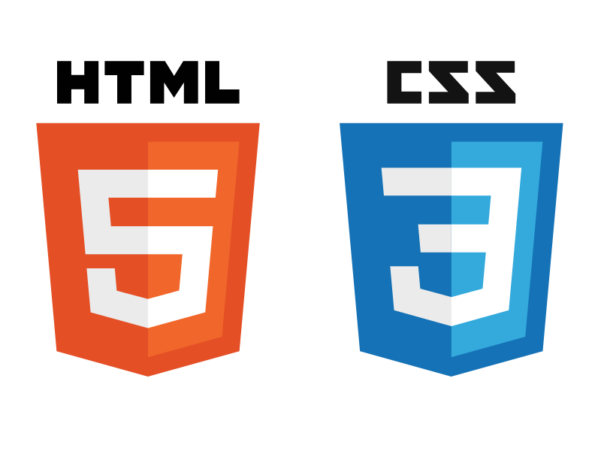

Fig 1.1

**1.3 OUTPUT:**

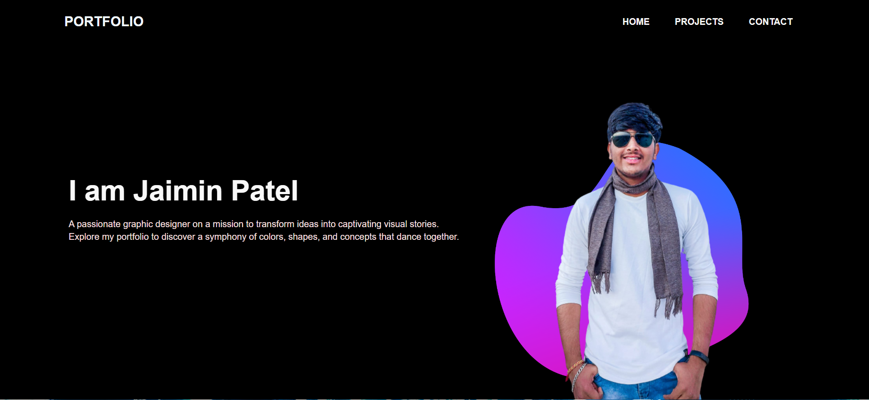

Fig 1.2



Fig 1.3

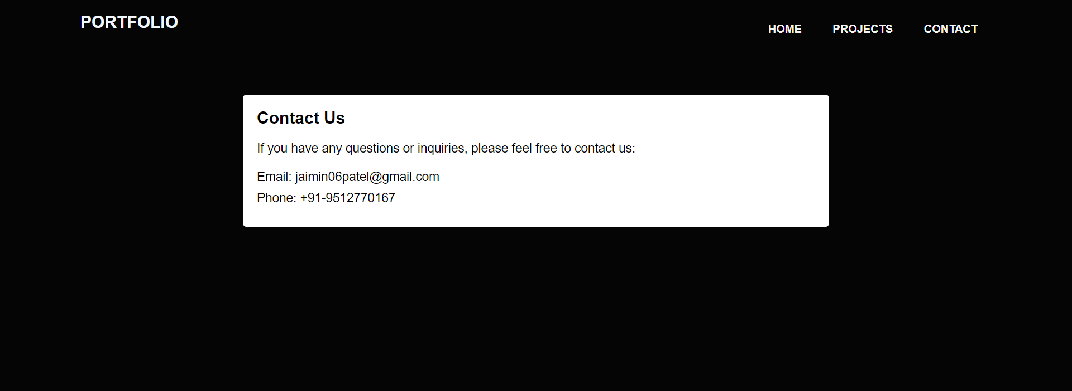

Fig 1.4

**Chapter 2. TEMPERATURE CONVERTER(CEL-FAH, FAH-CEL)**

**2.1 INTRODUCTION OF TASK 2:**

The Temperature Converter is a practical digital tool that simplifies the process of translating temperatures from one scale to another. This intuitive web-based application, crafted using HTML, CSS, and JavaScript, empowers users to effortlessly switch between Celsius and Fahrenheit scales with real-time calculations.

Harnessing the capabilities of modern web development, the Temperature Converter offers a user-friendly interface, enhancing convenience and accuracy for anyone seeking to bridge the gap between temperature metrics.

**2.1.1 OBJECTIVE:**

The primary objective of the Temperature Converter project is to create a user-friendly and efficient web-based tool that enables seamless conversion between Celsius and Fahrenheit temperature scales. The key goals include: Accuracy and real time conversion, user friendly interface etc.

**2.2 How to Implement ?**

Built using HTML, CSS, and JavaScript, this tool provides an intuitive interface where users can input a temperature value in either scale and instantly receive the equivalent measurement in the other unit. The real-time conversion process enhances accuracy and convenience, making it an ideal solution for quick temperature translations without the need for manual calculations.

**2.2.1 HTML(Hyper Text Markup Language):**

In this we used the form tag of HTML. The <form> tag in HTML is a fundamental element used to create interactive and user-friendly web forms. It serves as a container for various input fields, buttons, checkboxes, radio buttons, and other form elements, allowing users to submit data to a server for processing. It is often assisted by technologies such as Cascading Style Sheets and scripting languages such as JavaScript.

**2.2.2 CSS(Cascading Style Sheet):**

CSS Transitions are a powerful feature that allows you to smoothly animate changes in CSS properties over a specified duration. They enable you to create visually appealing and interactive effects on web elements, enhancing user experience and adding a sense of fluidity to your website. Flexbox is designed to provide an efficient way to arrange, distribute, and align elements within a container, especially when dealing with complex layout designs and responsive web development.

**2.2.3 JS(Java Script):**

JavaScript (JS) is widely-used programming language that plays a central role in web development. Initially created to enhance interactivity and dynamic behavior on web pages, JavaScript has evolved into a powerful, general-purpose programming language that can be used for a variety of applications beyond the web. It is an integral part of modern web development and is supported by all major web browsers, making it an essential tool for creating interactive and engaging user experiences.

‘const’ keyword is used to declare a constant variable. A constant is a variable whose value cannot be reassigned after it is initially assigned. It provides a way to create read-only variables, ensuring that their values remain unchanged throughout the program's execution.



Fig 2.1

**2.3 OUTPUT:**

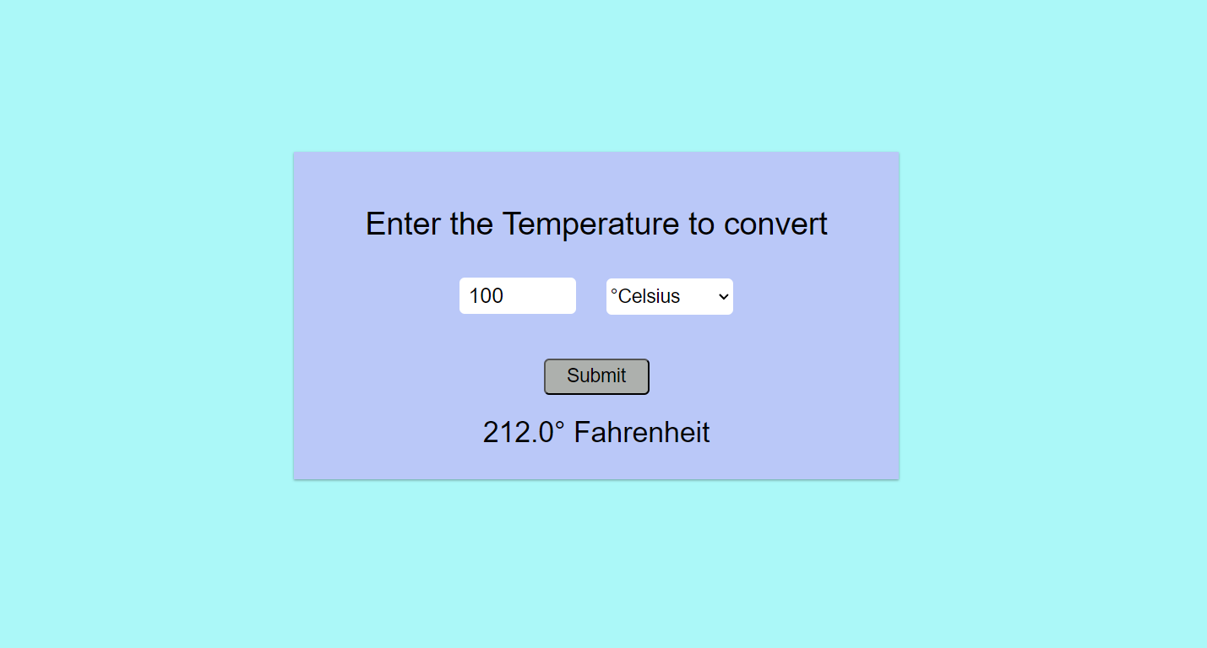

Fig 2.2